Bang & Olufsen Introduces the Contrast Collection

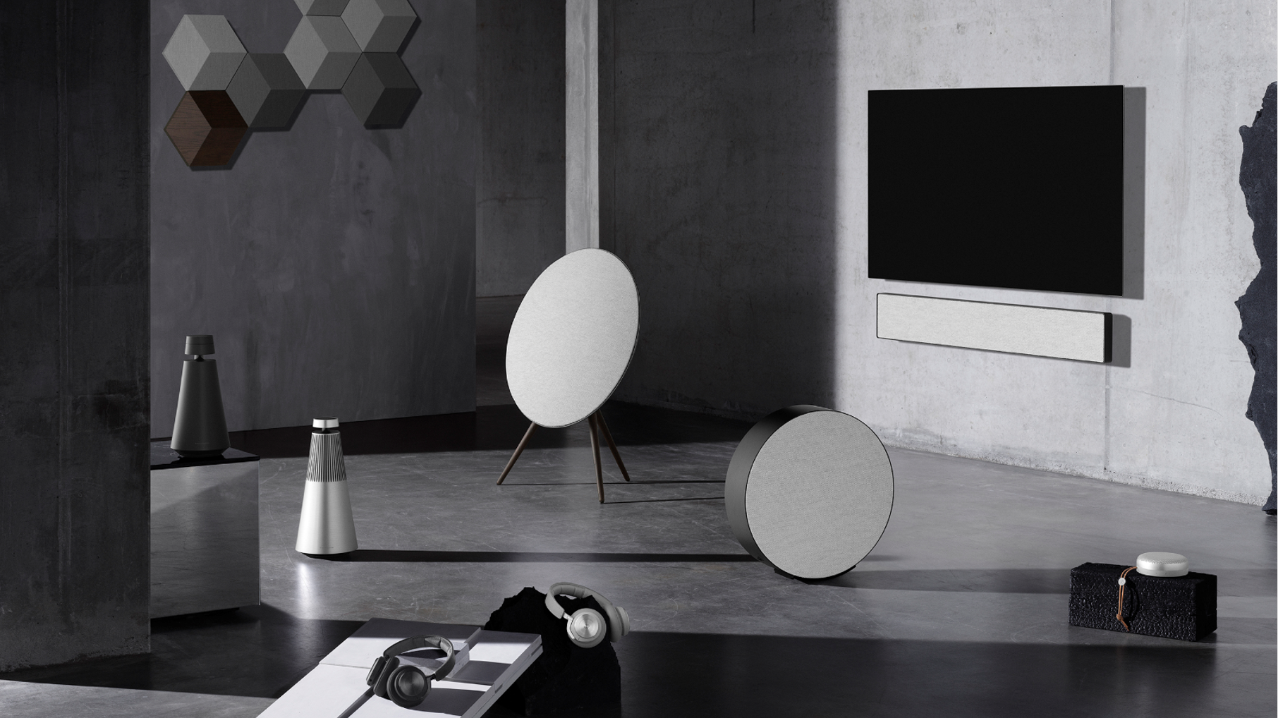

Bang & Olufsen today announces the Contrast Collection – a limited eight-piece collection created in collaboration with Danish design studio Norm Architects. Taking pleasure in difference, the Contrast Collection is an exploration of material combinations and tactile surfaces – between minimal and expressive, rough and smooth, light and dark, silence and loudness, harmony and noise – celebrating the shared curiosity and craftmanship between the two brands using material tensions that intrigue and excite.

“The Contrast Collection is a timeless interpretation of current interior trends focusing on tactility and textures. The combination of colour tones, materials and surfaces makes the collection a unique, new offering in a timeless design. The products are not only aesthetically aligned – they also deliver amazing Bang & Olufsen Signature Sound,” says Kresten Bjørn Krab-Bjerre, Design Director at Bang & Olufsen.

Light grey and anthracite colour palette
The colour palette of the collection was determined by exploring new ways of working with aluminium, which is a material that has become an integral and ubiquitous part of the Bang & Olufsen design aesthetic. Bang & Olufsen and Norm Architects wanted to turn the mirror-like aluminium into a soft and warm spectrum of colours that could put focus on textures applied to the aluminium. The light grey and anthracite colour tones were created from the same master sample of anthracite – an earthy, nearly-black grey – completed at the anodising treatment facility at Bang & Olufsen headquarters.

The brushed aluminium textures have been obtained after countless experiments with different surface treatments. There is a fine balance between presenting the application of a brushed effect as deliberate and controlled, and after a long process that started with hand brushing pieces of flat aluminium for added tactility, the aluminium experts of Bang & Olufsen managed to achieve giving Contrast its distinctive appearance.

Creating a new sound transparent wool fabric
Bang & Olufsen helped create its first transparent wool-fabric with Danish design textile company Kvadrat in 2015. For the Contrast Collection, Bang & Olufsen and Norm Architects wanted to explore a new type of textile to bring more tactility to the products and to integrate them beautifully in the home. The fabric – made of wool and viscose – originates from Kvadrat’s Hallingdal Fabric providing excellent durability, while the viscose adds brilliance and depth to the colour. The original version uses thick yarns, so the structure has been loosened to deliver high acoustic performance, while maintaining its rich texture.

Explore the full collection
The Contrast Collection consists of eight of Bang & Olufsen’s most popular speakers and wireless headphones:

- Beoplay A1 (RRP EUR 250 / USD 250 / CNY 1,898) – Ultra-portable Bluetooth speaker with a premium brushed aluminium grill and mottled tactile base. Contrast Collection colours: Natural Brushed.
- Beoplay H9 (RRP EUR 500 / USD 500 / CNY 3,898) – Premium wireless ANC headphones with a minimalist soft touch feel and a subtle, mottled concrete look on the housing. Contrast Collection colours: Grey Mist and Anthracite.

- Beoplay A9 (RRP EUR 2,750 / USD 3,250 / CNY 21,880) – Wireless, iconic design speaker with an anodised dark metal frame and light fabric to integrate into any home. Contrast Collection colours: Anthracite.

- Beosound Stage (RRP EUR 1,650 / USD 1,900 / CNY 12,580) – Powerful soundbar that enhances your TV experience with rich and durable textile fabric with linear elements and an emphasized horizontal weave. Contrast Collection colours: Anthracite.

- Beosound Shape (Grey Define & Dark Grey Define: RRP EUR 250 / USD 275 / CNY 1,900 (2 pieces), Wooden tile: RRP EUR 600 / USD 700 / CNY 4,998 (2 pieces)) – Modular speaker system with a horizontal weave in two colour ways that compliments the dark oak panel. Contrast Collection colours: Grey Define, Dark Grey Define, Wooden tile (Dark Oak).

- Beosound Edge (RRP EUR 3,600 / USD 3,800 / CNY 26,980) – Compact and powerful wireless speaker with thin, matte aluminium for elegance and wool mixed with viscose fabric for strength and durability. Contrast Collection colours: Anthracite.

- Beosound 1 (RRP EUR 1,650 / USD 1,900 / CNY 12,680) – Portable smart speaker uniquely treated with sandblasted effect for soft minimalistic feel that invites the touch. Contrast Collection colours: Anthracite.

- Beosound 2 (RRP EUR 2,200 / USD 2,500 / CNY 16,980) – Powerful speaker system with anodised aluminium and strong contrasts to allow the brush lines to be visible. Contrast Collection colours:
Natural Brushed.

Pricing and availability
The Contrast Collection will be available online, in select third-party retailers and in Bang & Olufsen stores from 16 January 2020 depending on region. To find out more, please visit https://www.bang-olufsen.com/en/story/contrast-collection

Follow the conversation at @bangolufsen on Instagram, Facebook, Twitter and YouTube using #ContrastCollection #BangOlufsen

For further information, please contact:
Allan Fatum, Sr. Manager, Head of Global PR
Email: afa@bang-olufsen.dk
Phone: +45 2965 0996

ABOUT BANG & OLUFSEN
Bang & Olufsen is a global luxury lifestyle brand founded in 1925 in Struer, Denmark, by Peter Bang and Svend Olufsen whose devotion and vision remain the foundation for the company. The rich heritage built around the relentless determination to create products that push the boundaries of audio technology continues to place the company at the forefront of audio innovation. Today, every Bang & Olufsen product is still characterized by the unique combination of beautiful sound, timeless design, and unrivalled craftsmanship. The company’s innovative and progressive audio products are sold worldwide in Bang & Olufsen monobrand stores, online, and in multibrand stores. The company employs approximately 900 people and operates in more than 70 markets. Bang & Olufsen’s shares are listed on NASDAQ Copenhagen A/S.

