Crafting Memories since 1925:
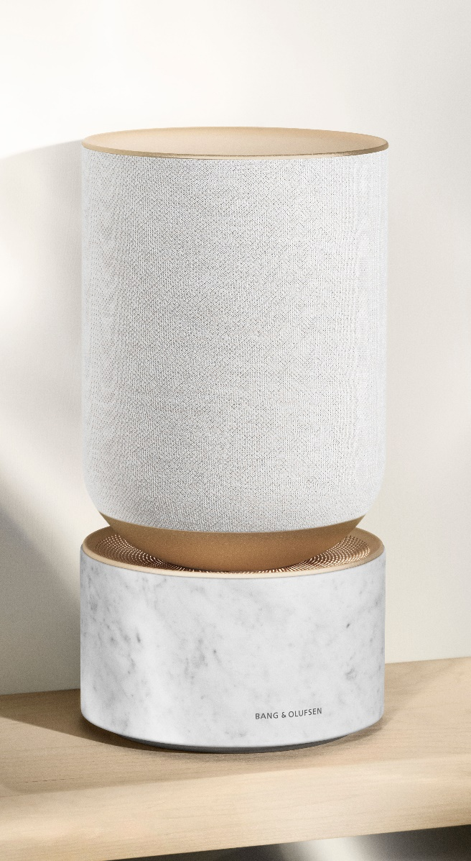
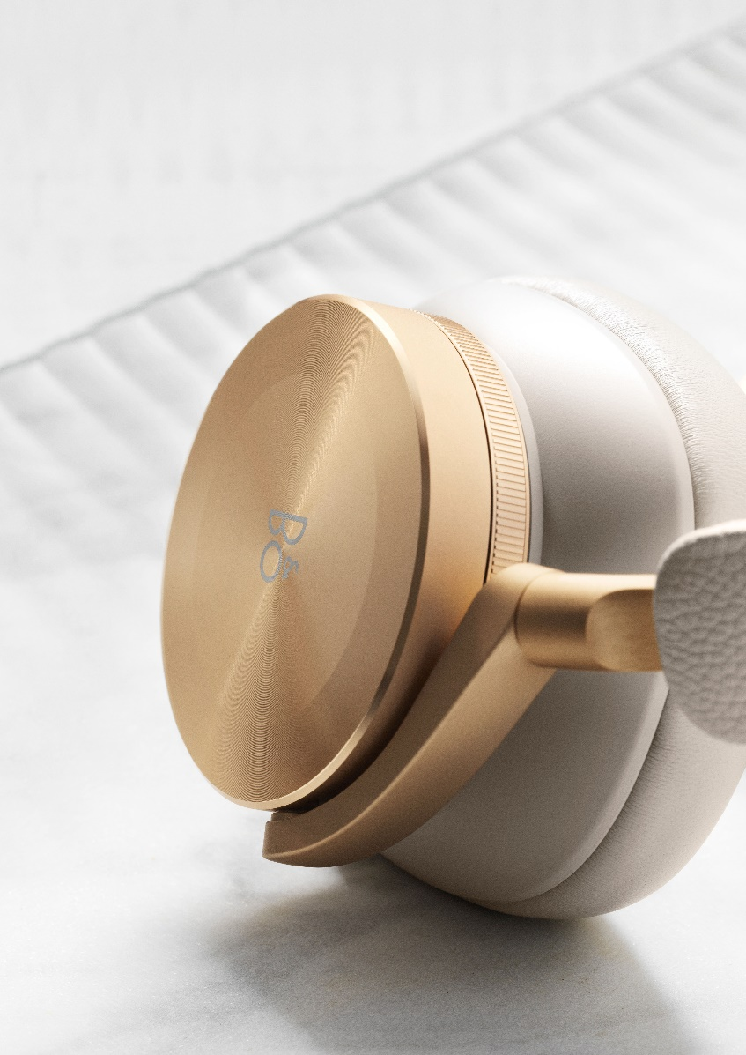
Bang & Olufsen Introduces the Golden Collection

Bang & Olufsen today announced the Golden Collection – a luxurious new colourway comprised of the Danish audio company’s most popular and enduring products.

The Golden Collection celebrates memories created with family and friends as we all spend more time home this year. From the modern design icon Beoplay A9 home speaker to the Danish audio company’s flagship active loudspeaker Beolab 90, the products in the collection are reimagined in colours and materials associated with warmth and lasting value: golden-hued aluminium, earth-toned textile, genuine lambskin, solid oak and Carrara marble.

“We love that our customers build emotional connections to Bang & Olufsen products, much like they do with a well-loved piece of furniture. Those connections become lasting memories. So not only does the Golden Collection celebrate our commitment to craftsmanship and longevity in design, it also celebrates our 95-year history of crafting memories together with our customers”, says Bang & Olufsen VP of Design Gavin Ivester.

The Golden Collection is comprised of nine products, each of which has become a staple of Bang & Olufsen’s product portfolio:

- Beosound Balance (2500 EUR) features golden-hued aluminium detailing, white knitted textile, and an elegant Carrera marble base – marking the first time that Bang & Olufsen has used Carrara marble. The organic nature of the marble means that no two speakers are identical, adding an extra layer of exclusivity to an already stunning speaker.
- Beoplay A9 (2750 EUR), a wireless speaker regarded as a piece of furniture by designers, features a gold tone aluminium ring, light oak legs and a sand-coloured fabric cover produced by Danish textile manufacturer Kvadrat.
- Beosound 2 (2000 EUR), known for its unique conical shape and powerful 360-degree dispersion of sound, features a double anodized gold tone aluminium body, produced at Bang & Olufsen’s aluminium factory in Struer, Demark.
- Beovision Harmony (from 19500 EUR), Bang & Olufsen’s premium TV experience known for its magical unfolding movement, features a new golden-hued aluminium sound centre, a matching floor stand, and a hand-crafted speaker cover made of aluminium and light oak veneer. Beovision Harmony comes with a Beoremote One remote control, made out of a single piece of gold tone aluminium.
- Bang & Olufsen’s state-of-the-art active loudspeakers, Beolab 50 (from 30000 EUR) and Beolab 90 (from 75000 EUR), feature golden hued aluminium detailing, and warm sand-coloured textile, and hand-crafted light oak accents.
- Customers can also take the Golden Collection to go with the award-winning Beosound A1 2nd Generation (250 EUR), which features a pearl-blasted golden-hued aluminium grill, a genuine leather strap and an aluminium tag displaying the Bang & Olufsen logo.
- For personal listening experiences, consumers can enjoy Beoplay H95 (800 EUR), the brand’s flagship headphones, or Beoplay E8 3rd generation (350 EUR), its best-selling true wireless earphones in the luxurious new colourway. Beoplay H95 features sand-coloured lambskin earcups and golden aluminium user interface. Beoplay E8 comes in a sand-coloured leather wrapped wireless charging case and feature elegant golden-hued aluminium detailing.

Pricing and availability
The Golden Collection will be available to purchase on www.bang-olufsen.com, in Bang & Olufsen and select third party retailers from November 17, 2020 - Bang & Olufsen’s official 95th birthday. To find out more, follow the conversation at @bangolufsen on Instagram, Facebook, Twitter and YouTube using #GoldenCollection

For further information, please contact:
Allan Fatum, Sr. Manager, Head of Global PR
Email: afa@bang-olufsen.dk
Phone: +45 2965 0996

ABOUT BANG & OLUFSEN
Bang & Olufsen is a global luxury lifestyle brand founded in 1925 in Struer, Denmark, by Peter Bang and Svend Olufsen whose devotion and vision remain the foundation for the company. The rich heritage built around the relentless determination to create products that push the boundaries of audio technology continues to place the company at the forefront of audio innovation. Today, every Bang & Olufsen product is still characterized by the unique combination of beautiful sound, timeless design, and unrivalled craftsmanship. The company’s innovative and progressive audio products are sold worldwide in Bang & Olufsen monobrand stores, online, and in multibrand stores. The company employs approximately 900 people and operates in more than 70 markets. Bang & Olufsen’s shares are listed on NAS DAQ Copenhagen A/S.

