Bang & Olufsen Announces New Beoplay E8 2.0 with Wireless Charging Case

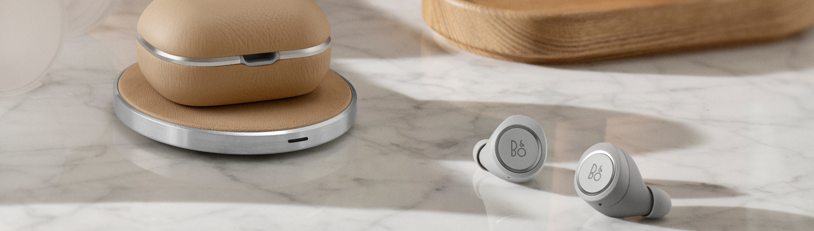

Copenhagen, 3 January 2019 – Offering superior sound, beautiful design in exclusive materials and intuitive touch control on the earphones that gives you total control over music, calls and voice commands, Bang & Olufsen’s first true wireless earphones Beoplay E8 were designed for people who don’t want to compromise sound and design for true wireless freedom.

Today, Bang & Olufsen is announcing the all-new Beoplay E8 2.0 that comes with improvements to the design of the original product as well as features requested by the Bang & Olufsen community:

- The premium leather charging case has been redesigned with a new, more exclusive form factor and comes with wireless charging to make Beoplay E8 2.0 truly and totally wireless. You can now charge Beoplay E8 2.0 simply by placing the case on a wireless charging pad.
- The wireless charging case now holds three full charges, which gives up to 16 hours playing time. This is an improvement on the 12 hours offered with the original and is easily enough for a day’s listening on the move. An LED light on the front of the case shows you the state of charging, while three LED lights on the back of the case show you the number of full charges left in the case.
- On the inside of the charging case, the earphones are now surrounded by a beautiful inlay of brushed single or double anodized aluminum depending on colour.
- The wireless charging cases comes with USB-C for charging the earphones with a cable.

Introducing the Bang & Olufsen Wireless Charging Pad

For charging in style, Bang & Olufsen is also announcing a new wireless charging pad for use with Beoplay E8 2.0.

The charging pad is crafted from luxurious materials, including brushed aluminum and cowhide leather, designed to last and to age beautifully. As the perfect companion for your Beoplay E8 2.0 as well as your smartphone, the wireless charging pad supports regular charging (5W) and fast charging (10W).

Existing Beoplay E8 owners can also get wireless charging

As the original Beoplay E8 earphones fit perfectly into the new wireless charging case, Bang & Olufsen will make it possible for existing owners of Beoplay E8 to enjoy the benefits of wireless charging. The charging case will be sold separately, and you will also be able to buy separate left and right earphones.

Bang & Olufsen Signature Sound

Just like the original Beoplay E8, the new earphones come tuned by Bang & Olufsen’s acclaimed sound engineers for a rich, full-bodied and precise soundstage that will leave your ears wanting more. Each earpiece has a 5.7mm dynamic speaker, a small electromagnetic transducer, NFMI technology (Near Field Magnetic Induction) and a Bluetooth 4.2 chip with Digital Sound Processing that allows for dynamic sound tuning and sound without interruption. Users will also be able to tune the sound themselves in the Bang & Olufsen app for Android and iPhone.

Pricing and Availability
Beoplay E8 2.0 comes complete with a premium leather wireless charging case, five ear tips and UBS-C charging cable. The earphones are launching in the colours Black, Indigo Blue, Natural and Limestone and retail for 350 EUR/USD. All colours will be available at www.bang.olufsen.com/earphones/beoplay-e8-2, Bang & Olufsen stores and selected third party retailers from 14 February 2019.

The Bang & Olufsen Wireless Charging Pad will be available in matching colours Black, Indigo Blue, Natural and Limestone. The retail price yet to be disclosed. Separate Beoplay E8 2.0 left and right earphones retail for 125 EUR/USD and the wireless charging case will retail for 200 EUR/USD. The Wireless Charging Pad, Wireless Charging Case and separate Beoplay E8 2.0 earphones will be available from April 2019.

To find out more, please visit and follow the conversation at @bangolufsen on Instagram, Facebook, Twitter and YouTube using #BeoplayE8

Download hires images on https://www.flickr.com/photos/bangandolufsen

For further information, please contact
Allan Fatum, Global PR Manager
Email: afa@bang-olufsen.dk
Phone: +45 2965 0996

ABOUT BANG & OLUFSEN
Bang & Olufsen is a global luxury lifestyle brand founded in 1925 in Struer, Denmark, by Peter Bang and Svend Olufsen whose devotion and vision remain the foundation for the company.

The rich heritage built around the relentless determination to create products that push the boundaries of audio technology continues to place the company at the forefront of audio innovation. Today, every Bang & Olufsen product is still characterized by the unique combination of beautiful sound, timeless design, and unrivalled craftsmanship.

The company’s innovative and progressive audio products are sold worldwide in Bang & Olufsen monobranded stores, online, and in multibranded stores. The company employs over 1,000 people and operates in more than 70 markets. Bang & Olufsen’s shares are listed on NAS DAQ Copenhagen A/S.

