Bang & Olufsen INTRODUCES BEOSOUND EMERGE, An INCREDIBLY slim YET POWERFUL HOME SPEAKER
_
PRESS RELEASE

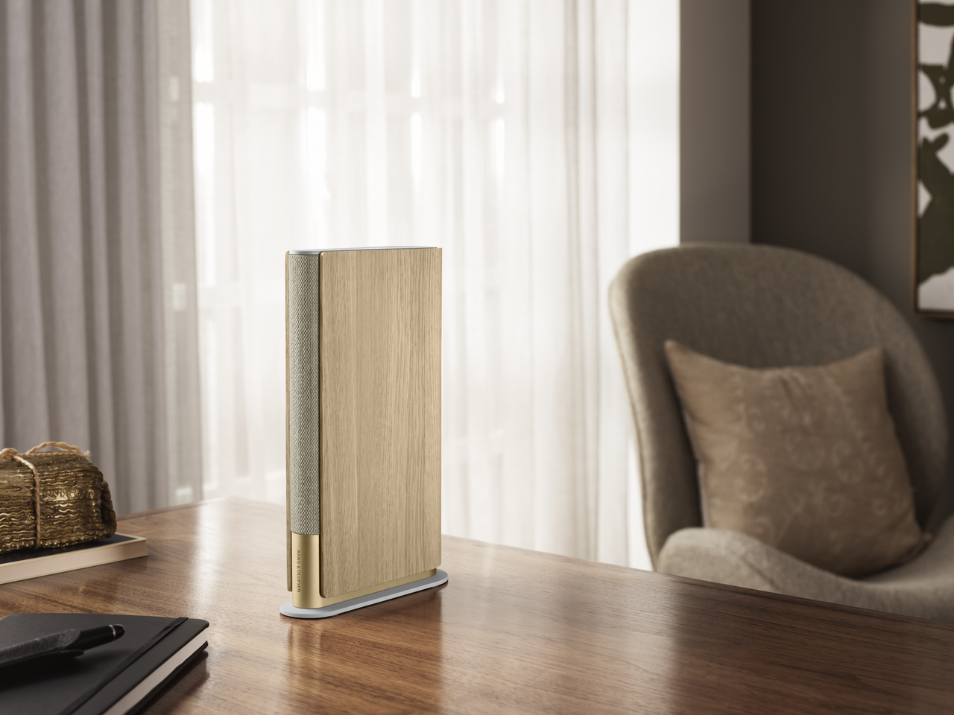
Bang & Olufsen today introduced Beosound Emerge designed by Benjamin Hubert of Design Agency LAYER, a home speaker with a slim silhouette that delivers rich and powerful sound experiences to suit any space. Created with a passion for music, design, and craftsmanship, Beosound Emerge is the perfect balance between the elegant beauty of an interior object combined with the technical performance of a speaker, built for longevity.
Technical Spec.
—
Product dimensions L x H x D
25.5 x 16.5 X 6.7 cm

Weight
1.38 Kg

Speaker drivers
1 x 4” woofer drivers
1 x 1.45” mid-range drivers
1 x 0.6” tweeter

Power Amplifiers
Non-clipped peak(W)1 ×60 W class D for woofer
1 ×30 W class D for mid-range
1 ×30 W class D for tweeter

Frequency Range
45 -22000 Hz

Power Consumption
Normal usage:15 Watt
Network stby: 4,5 Watt

Power Supply
90 -240 V, 50/60Hz

Operating Conditions
Temperature: 10-40°C
Humidity: 30-95%

Features
Active Room Compensation
Beosonic
Bang & Olufsen Radio
TuneIn via Google Assistant Bluetooth
Line-in/optical
Google Assistant
Airplay 2
Chromecast

Wireless Networks
Dual band WLAN 2.4 & 5 GHz
IEEE 802.11 b/g/a/n/ac
Bluetooth 5.0

Microphones
Yes

Connections
1 x Ethernet 10/100 Mbit
1 x Line-in/ Optical combi-jack
1 x Power via USB-C
1 x Service port via micro USB

Multiroom
Multiroom technologies from Apple AirPlay2 and Chromecast Multiroom are integrated and ready for you to create a connected speaker setup with Beosound Emerge

“The vision for Beosound Emerge was to create the slimmest speaker possible that could still deliver full range, ultra-wide sound despite its size through its revolutionary driver configuration. Whether placed on a bookshelf in the bedroom or a tight corner of the kitchen, Beosound Emerge’s slim design allows you to extend your music to a new room or complement an existing speaker in the same area without taking up extra space”, says Christoffer Poulsen, Senior Vice President and Head of Product Management at Bang & Olufsen.
IMPOSSIBLY SLIM, SURPRISINGLY POWERFUL
Designed in collaboration with Benjamin Hubert from the experience design agency LAYER, Beosound Emerge is a versatile speaker inspired by the compact form factor of a book. The slim, sculptural structure is the quintessential bookshelf speaker, designed to seamlessly sit anywhere in the home, whether discreetly tucked away or prominently on display. Built to extend sound without taking up space, Beosound Emerge’s resemblance to an interior object allows it to seamlessly integrate alongside books and other domestic objects. The side panels wrap around the speaker like the cover of a book, while the front of the speaker is marked with Bang & Olufsen’s logo in the same way the spine of a book features the author’s name.
Designer
—
Benjamin Hubert, LAYER
Finishes & Materials
—

Gold Tone: Oak wood, knitted Kvadrat fabric, aluminium

Black Anthracite: Aluminium, polymer, polymer cable

Using tactile and warm materials inspired by residential interiors, Beosound Emerge Gold Tone features an oak wood cover that wraps around the woven Kvadrat textile on its spine. The pearl-blasted aluminium, anodised in a gold tone, visually grounds the speaker in luxury and is aesthetically pleasing from every angle due to its tapered silhouette. The speaker cover can also be chosen in a high-grade aluminium Black Anthracite finish with a pearl-blasted grill. The polymer side panels feature a vertical corrugated pattern that accentuates the slim lines of the speaker. This sensitive material approach softens technology, highlighting Bang & Olufsen’s dedication to craftsmanship.

“As a studio, we like to build long-term partnerships with the brands we work with and Beosound Emerge is our second collaboration with Bang & Olufsen. The super slim speaker has been designed to minimise the physical footprint and maximise the audio output as a response to the real estate in people’s homes being at an unprecedented premium. At LAYER, we believe that technology should enable happiness but doesn’t necessarily need to be an expression in its own right, so it was equally important for us to create a new architectural format with a strong sculptural sensibility and a more domestic material palette that will stand out in the saturated audio market while seamlessly fitting into the home”, says Benjamin Hubert, founder of LAYER.

Beosound Emerge’s user interface is intuitively incorporated into the top of the product. The buttons can be activated through soft touch where users can pause music and change track or easily access favourite radio stations and playlists. The volume adjustment is a unique experience, enabling a circular motion to adjust up or down for a smooth and sensory interaction.
FULL RANGE, ULTRA WIDE SOUND
Bang & Olufsen’s dedication to creating a home speaker inspired by interior objects has resulted in a unique loudspeaker driver configuration that enables a full-range sound experience from a slender form. To achieve this level of acoustic quality, the designers worked in close collaboration with the Bang & Olufsen’s acoustic engineers.

The 37mm midrange is mounted at an angle to maintain the narrow design of Beosound Emerge, emitting sound from the front along with the 14mm soft dome tweeter. The output of the 100mm side-firing woofer is guided to the back of the product, the total result being a sound dispersion wide enough to fill the room with sound. The low frequency range is improved by the built-in active room compensation technology that customizes the sound design for the placement of the speaker in your room, ensuring a flawless sound experience in every listening environment.
DESIGNED FOR LONGEVITY
Pricing & Availability
—
Beosound Emerge in Gold Tone from (RRP 749 EUR/669 GBP/5599 DKK).

Black Anthracite from (RRP 599 EUR / 539 GBP / 4499 DKK).

Both colourways are available online and in Bang & Olufsen stores in selected European markets from 15th April 2021. Global availability from Autumn 2021.

Bang & Olufsen’s commitment to longevity across its product portfolio is also prevalent in Beosound Emerge. The speaker has been modularly designed, providing access to Bang & Olufsen’s new replaceable connectivity module introduced in Beosound Level.
The module has been frontloaded with enough processing power and connectivity technology to receive new performance updates and features for years to come. If the connectivity and streaming technology ever becomes outdated, the module can be replaced with the latest technology updates, future proofing the speaker.

EXPANDED MUSIC EXPERIENCE
Beosound Emerge can be added to Bang & Olufsen’s Connected Speakers set up to deliver music throughout the home. Beosound Emerge can be placed in a small room to fill the space with powerful and clear sound. Equally, it can be used to complement an existing speaker set-up in the same space and is the perfect accompaniment to Beoplay A9 or Beosound Balance or any of the Bang & Olufsen Connected Speakers.
For an even more immersive and impactful music experience, easily stereo pair two Beosound Emerge’s together for stereo listening sessions. Developed by Bang & Olufsen, the wireless stereo experience is a new technology that will soon be available on a range of speakers including Beosound Balance and Beosound Level. With its minimalistic footprint, Beosound Emerge can bring a true Stereo experience to the home office as a desktop solution, or other smaller rooms where space is scarce.
MULTI-ROOM FUNCTIONALITY AND VOICE CONTROL
Beosound Emerge supports Apple Airplay 2, Chromecast and features a built-in radio and microphone for voice control. Bang & Olufsen’s proprietary Beolink connectivity will be available on Beosound Emerge via an over-the-air software update in the autumn. Play music and check the news completely hands free with Google Assistant.
About Bang & Olufsen
—
Bang & Olufsen is a luxury audio brand founded in 1925 in Struer, Denmark, by Peter Bang and Svend Olufsen whose devotion and vision remain the foundation for the company. For nearly a century, Bang & Olufsen has been pushing the boundaries of audio technology and the company continues to sit at the forefront of acoustic innovation.
Today, every Bang & Olufsen product is still characterized by the unique combination of beautiful sound, timeless design, and unrivalled craftsmanship. The company’s innovative and progressive products are sold worldwide in Bang & Olufsen stores, on bang-olufsen.com and in select retailers. The company employs approximately 900 people and operates in more than 70 markets. Bang & Olufsen’s shares are listed on NASDAQ Copenhagen A/S.
About LAYER
—
Benjamin Hubert is an award-winning British design entrepreneur and founder of London creative agency, LAYER. LAYER is focused on experience-driven design for both the physical and digital worlds. Led by Benjamin and a growing creative team, LAYER is partnering with forward-thinking brands to create products that will help define the way we live, work and communicate in the future, from A.I to smart wearables and furniture systems, to the next generation of media devices and mobile communication tools. To find out more, visit @layer_design, @benjaminhubert and layerdesign.com.

Follow the conversation
—
To find out more, follow the conversation at @bangolufsen on Instagram, Facebook, Twitter, YouTube and Linkedin using #BeosoundEmerge.

Contact
—
Bethan Beckett
Global PR Manager
bebe@bang-olufsen.dk
+45 9684 1888
Allan Fatum
Sr. Manager – Head of Global PR
afa@bang-olufsen.dk
+45 2965 0996

